CMPE 451

Concerter

Web User Manual

You can go to the website by clicking the following link.
http://concerter.eu-central-1.elasticbeanstalk.com/login

1.1) The Sign Up Page

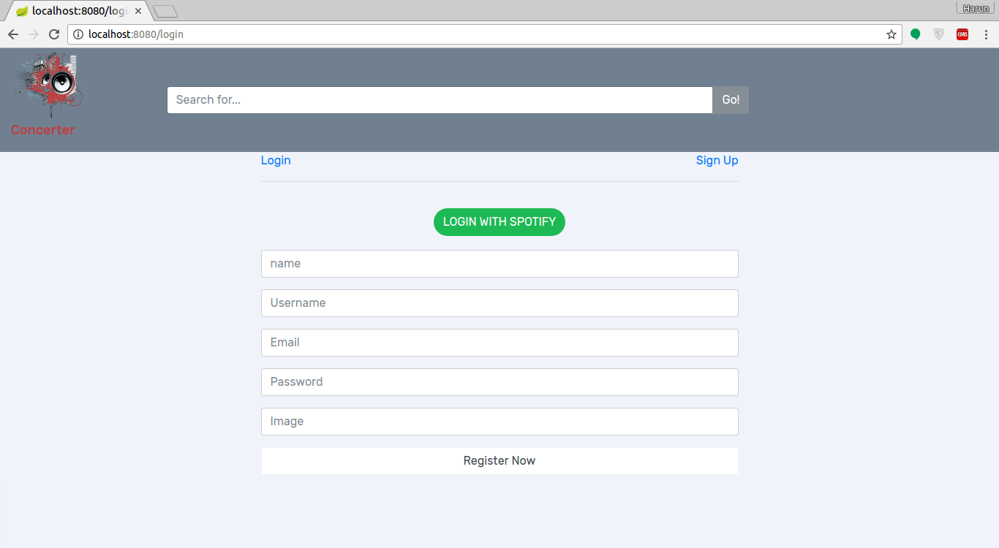
You have to sign up in order to access the site. You can either access the site with his/her Spotify account or by entering the above information. After entering the information, you either can press the Register Now button or pushing the enter button in order to sign up.

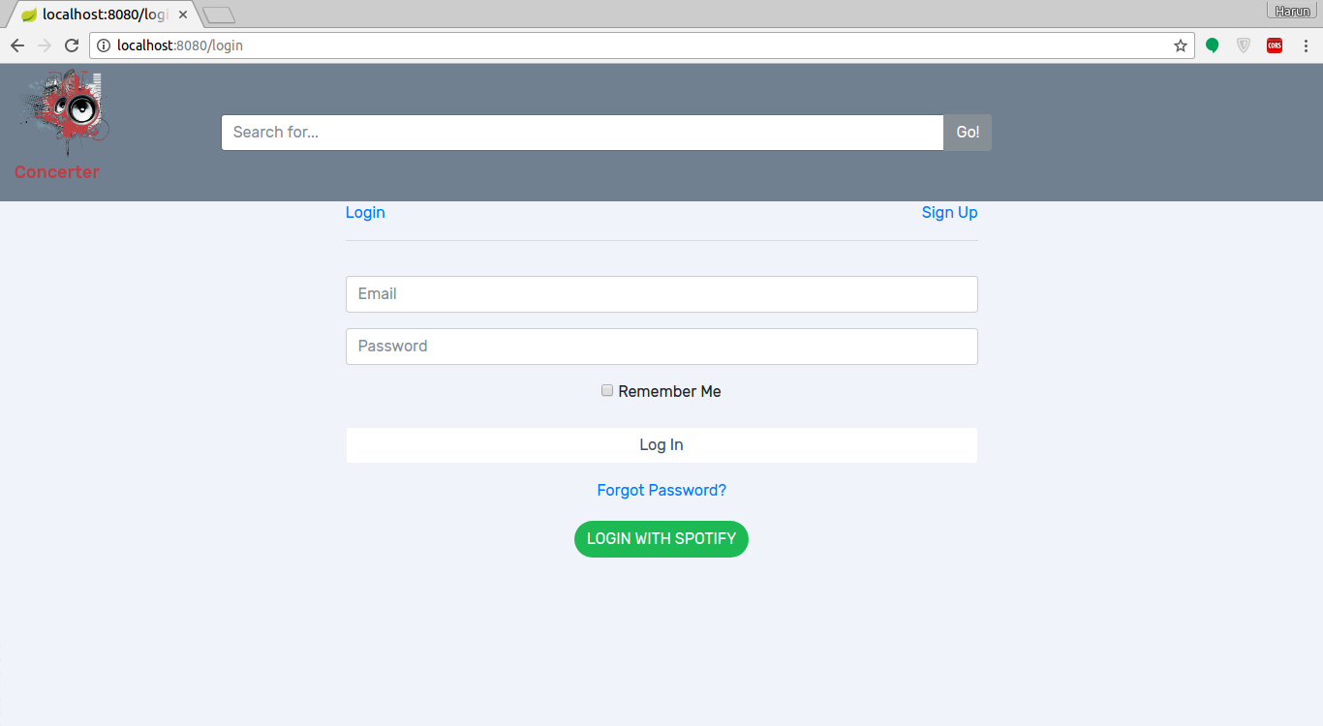
After signing up you are redirected to the login screen.
1.2) The login page

You have to enter your email address and password you created. When done, you are redirected to the home page.
2) The Home Page

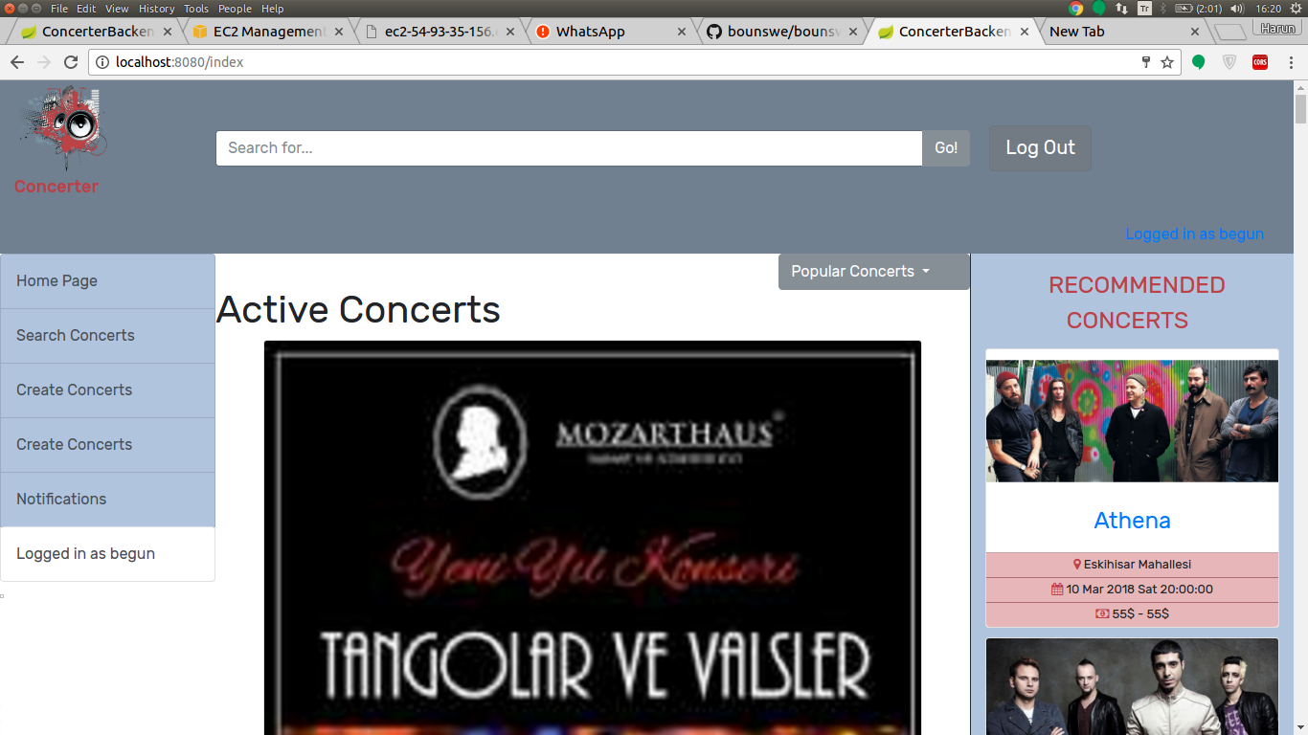
You can view the concerts on the middle of the home page, whereas the concerts recommended to you will appear on the right of the page. On the top menu, there is a search bar where you can perform basic search activity. On the right bar, there is a navigation menu. The first link is the home page. The second is search concerts, where you can perform advanced search. To create concerts, you can click on the create concert link. To view the notifications, you have to click the notifications button. The last link will take you to the profile page.

On the image in the button, you can see the details, shown for a concert.

3)The concert creation page:
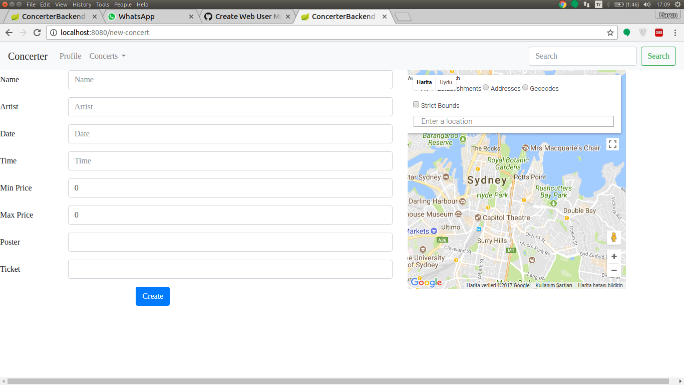
You have to enter the above information in order to create a concert. The minimum price and maximum price will show the price range. You have to paste a poster image link and a link for the other users to click in order to buy tickets.

4.1)The Advanced Search Page
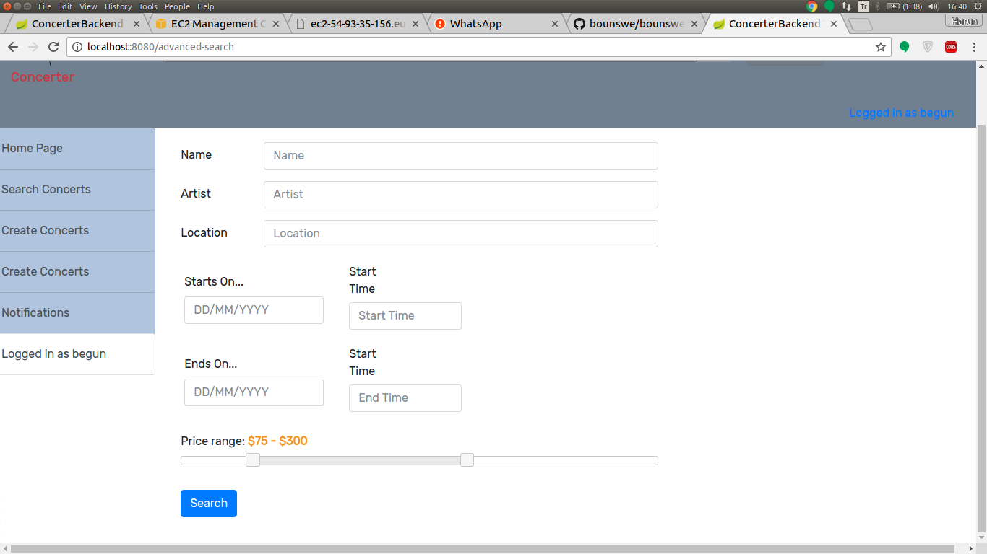
To perform advanced search and find concerts, you can do it by entering the information you wish. The site will redirect you to the search result page.

4.2) Search Result Page
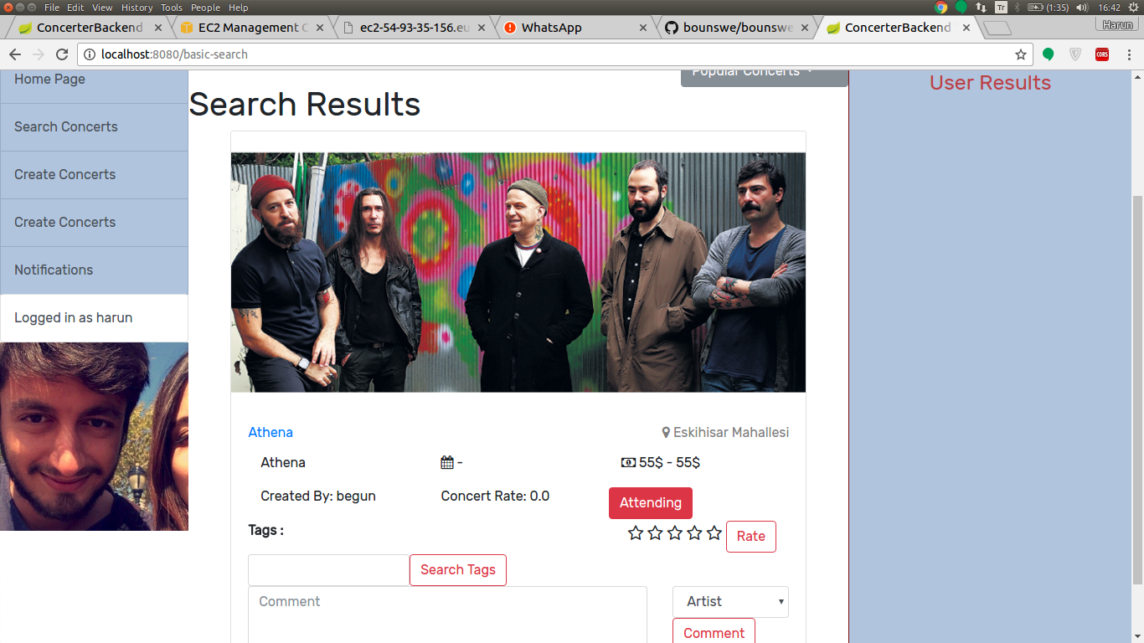
5)The Concert Page

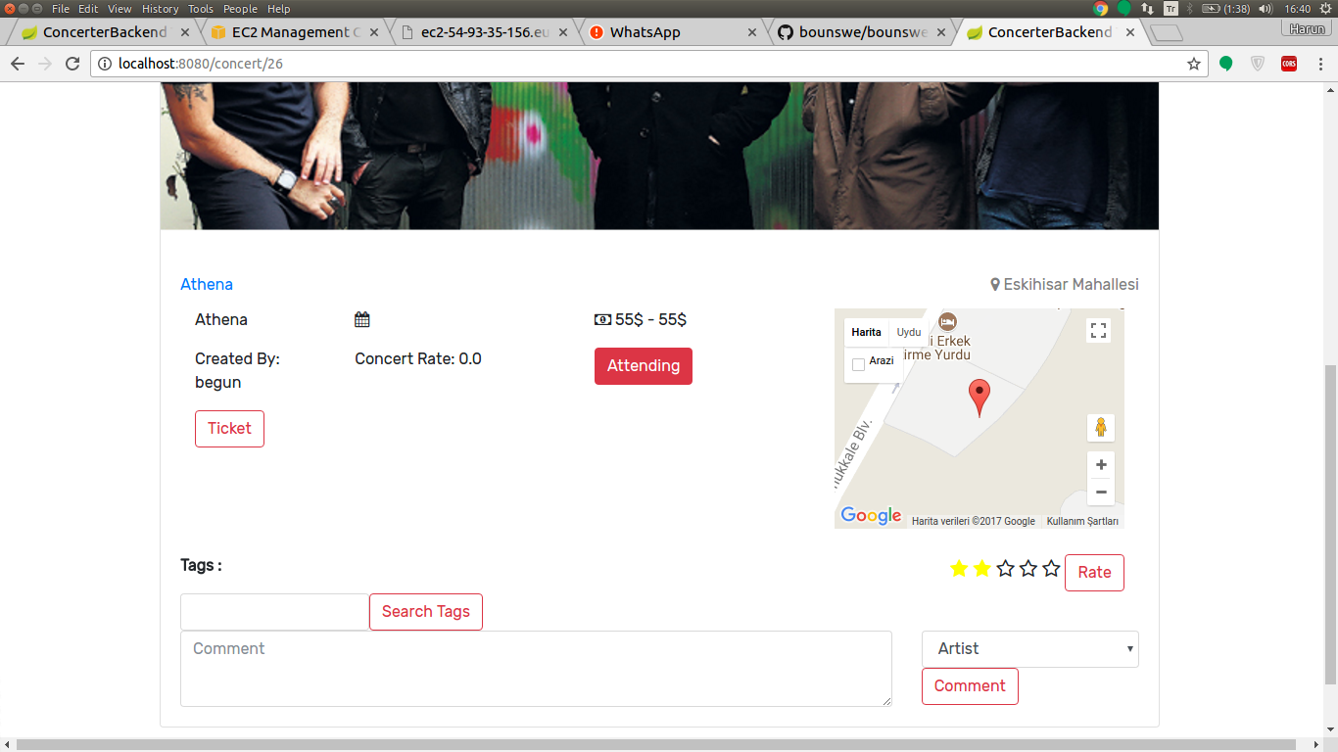
You can view the concert page by clicking any concert link on the site. The link will take you to the concert page of that concert. You can add semantic tags by searching the semantic tag and by clicking add on the relevant tag you were searching for. You can comment on the concert by specifying what your comment is about. The comment will then be shown with a relevant icon, specifying what the concert is about. You can rate the concert by clicking on the star and then clicking on rate. You can mark to the concert as attending. The location of the concert place is shown on the map.

